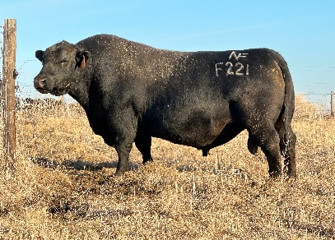
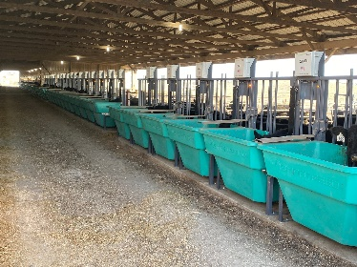
 |  |  | 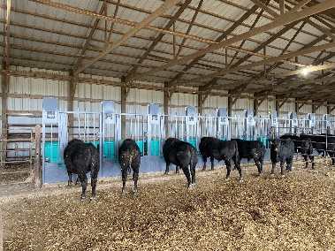  pAID Spring Internship  Nichols Farms | www.nicholsfarms.biz
About us |  |  | cow/calf
Nichols Farms is a beef genetics company located in Bridgewater, Iowa since 1956. The operation consists of about 1200 cows, we will sell approximately 500 yearling bulls every year, along with 250 heifers. There are 3 main breeds (Angus, Simmental, South Devon) along with composites that are ran in the herd. |  |  | Calving- Assist with the calving of heifers and cows along with general health but includes tagging, vaccinations, and record keeping (utter score, hoof tape, disposition, ect.)  Reproduction- Protocols for 7 and 14 day CIDRS, Estrumate, and AI heifers. Embryo transfer on some cows and pregnancy ultrasound.  Other- Equipment operation, loading and unloading livestock, sorting, pairs to pasture, bulls to pasture.
time line |  |  | bull barn
Internship is preferred March-May/June but will accommodate and housing will be provided.  Jan- Yearling bull sale is the last Saturday in January  March- Calving, Semen test, Backfat and Ribeye Ultrasound, Bulls come off Feed Efficiency Test and get weighed.  April- Start to CIDR heifers, calving continued.  May- CIDR heifer cont., Estrumate and breed heifers and cows. Start to move heifers to the bull barn for Feed Efficiency Test, end calving.  June- Finish all breeding, embryo cows, all heifers on Feed Efficiency/ weigh/ start test, hay season, summer maintenance and upkeep. |  |  | Bulls- General health, Sensehub Smart Tags, Semen test, Ribeye and backfat ultrasound, disposition, foot scores.  Feed- Rations and feedstuff percentages and samples, loading and mixing with a feed truck or wagon, feed delivery, monitoring intake.  Feed Efficiency- Maintenance, operation, and data monitoring of the 60 Smartfeed (bunks), 10 Smartscale (animal weight), and 2 Greenfeed (monitors gases) systems from the C-LOCK company.
 |  |  | data
-EPD’s -Ultrasounds
-Feed Efficiency (C-LOCK System) -Genotypes
-Performance Phenotypes -BRD

NICHOLS@NICHOLSFARMS.BIZ |  |  | 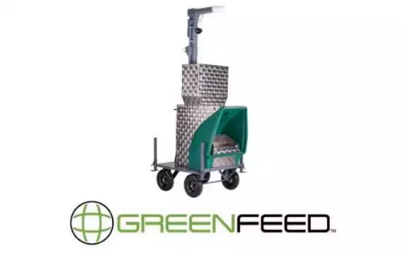  641-369-2829

